Chapter-9 (Practice Questions)

- Show a complete timing diagram for a 3-bit up/down counter that goes through the following sequence. Indicate when the counter is in the UP mode and when it is in the DOWN mode. Assume positive edge-triggering. 0, 1, 2, 3, 2, 1, 2, 3, 4, 5, 6, 5, 4, 3, 2, 1, 0
- Develop the Q output waveforms for a 74HC190 up/down counter with the input waveforms shown in Figure. A binary 0 is on the data inputs. Start with a count of 0000.
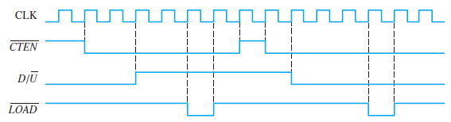
- Repeat above Problem if the CTEN is inverted with the other inputs the same.
- Determine the sequence of the counter in Figure.
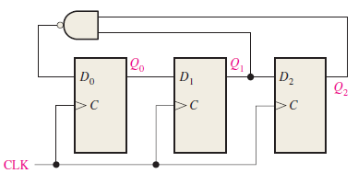

- Determine the sequence of the counter in Figure 9–74. Begin with the counter cleared.

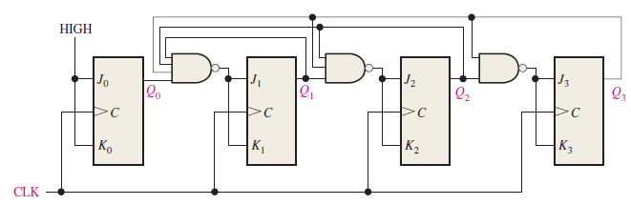
- Design a counter to produce the following sequence. Use J-K flip-flops. 00, 10, 01, 11, 00, ….
- Design a counter to produce the following binary sequence. Use J-K flip-flops. 1, 4, 3, 5, 7, 6, 2, 1, ….

- Design a counter to produce the following binary sequence. Use J-K flip-flops. 0, 9, 1, 8, 2, 7, 3, 6, 4, 5, 0, …
- Design a binary counter with the sequence shown in the state diagram of Figure. (using D flip flop)
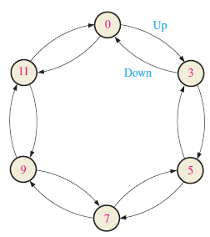
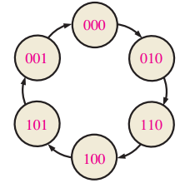
- Design a counter by using D -flip flop only with the irregular binary count sequence shown in the state diagram of Fig. Include Next-state table, transition table, Karnaugh maps and final circuit.

11. If a 5-bit ring counter has an initial state 10101, determine the waveform for each Q output

12. Design a modulus-10 Johnson counter using J K flip flop. Write the sequence in tabular form.

